**Supplementary material contains:**

**Supplementary Figure S1:** Percentage of DMS by feature type and distribution along chromosomes

**Supplementary Figure S2:** GO enrichment analysis for the genes containing DMS belonging to categories infection-induced and intergenerational

**Supplementary Figure S3:** Disease tolerance, measured as the slope of the regression between body condition index and parasite count, is higher in offspring from infected fathers compared to offspring from control father.

**Supplementary Table S1:** DMS annotation (separate spreadsheet)

**Supplementary Table S2:** Composition of our dataset

**Supplementary Figure S1: Percentage of DMS by feature type and distribution along chromosomes. A.** Percentage of DMS (outer circle) and non DMS (inner circle) found in intergenic regions, introns, exons and promoters **B.** Distribution of DMS on chromosomes

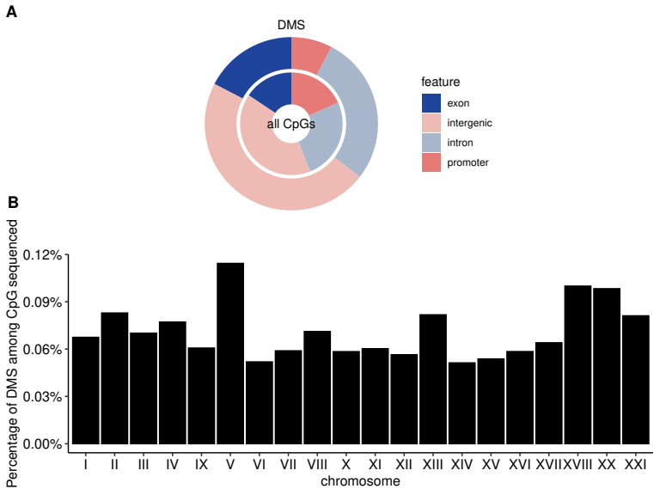

**Supplementary Figure S2: GO enrichment analysis for the genes containing DMS belonging to categories infection-induced and intergenerational.**

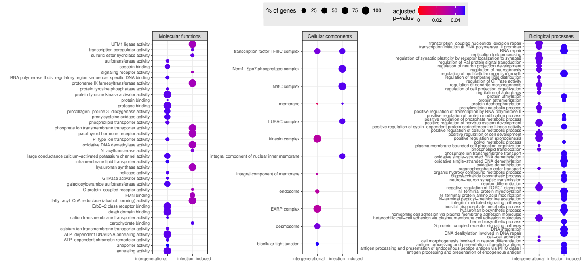

**Supplementary Figure S3: Disease tolerance, measured as the slope of the regression between body condition index and parasite count, is higher in offspring from infected fathers compared to offspring from control father.**

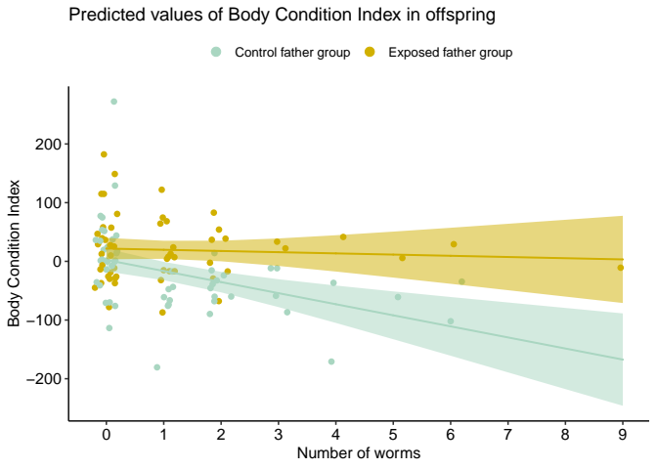

**Supplementary Figure 4.** Link between tolerance, paternal effects and DNA methylation at the identified DMS for (A) infection-induced DMS and (B) intergenerational DMS. Tolerance, i.e. the slope of Body Condition Index (BCI) by number of worms, is influenced by the paternal treatment. The interaction with the first PCA axis from methylation values at DMS is represented, but not statistically significant. Black slope: PCA1= -10; Red slope: PCA1=10.

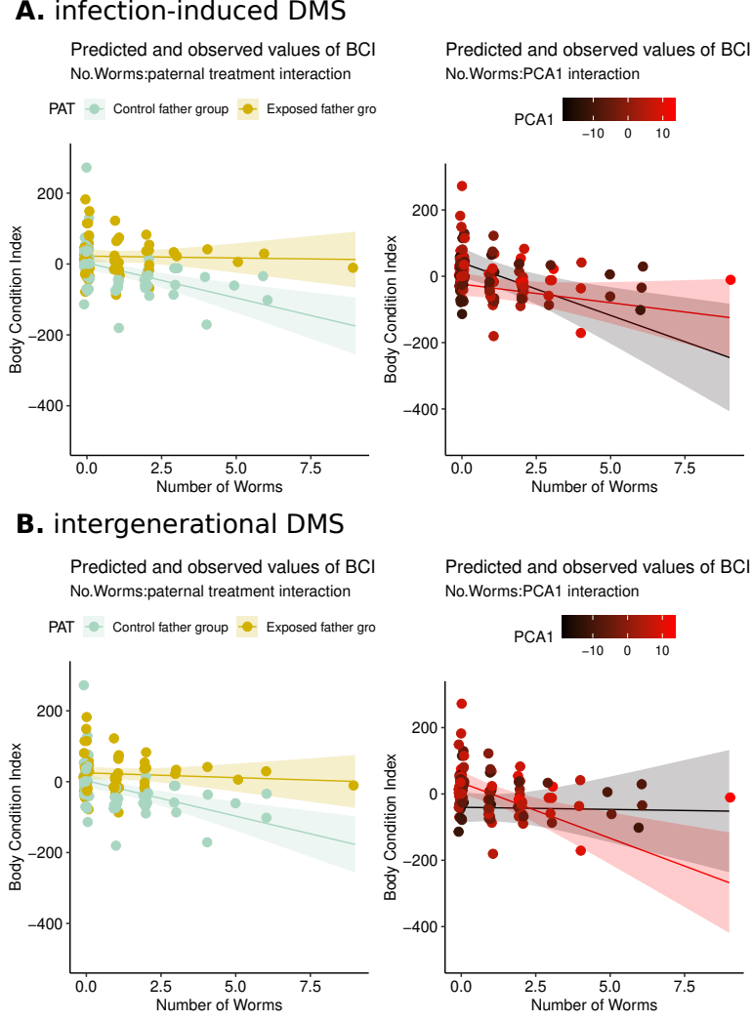

**Supplementary Table S2: Composition of our dataset**

|  |  |  |  |  |  |  |  |  |
| --- | --- | --- | --- | --- | --- | --- | --- | --- |
| treatment | G1 control G2 control | | G1 control G2 infected | | G1 infected G2 control | | G1 infected G2 infected | |
| sex | male | female | male | female | male | female | male | female |
| brother pair |  |  |  |  |  |  |  |  |
| BP04 | 1 | 3 | 2 | 2 | 2 | 2 | 3 | 1 |
| BP05 | 1 | 3 | 0 | 3 | 3 | 1 | 2 | 2 |
| BP16 | 3 | 1 | 1 | 1 | 4 | 0 | 2 | 2 |
| BP30 | 2 | 1 | 1 | 2 | 1 | 3 | 2 | 2 |
| BP31 | 2 | 1 | 1 | 3 | 0 | 3 | 1 | 2 |
| BP34 | 2 | 0 | 2 | 2 | 2 | 0 | 2 | 1 |
| BP46 | 2 | 2 | 2 | 1 | 3 | 0 | 3 | 1 |
| BP49 | 0 | 4 | 2 | 2 | 1 | 3 | 1 | 1 |